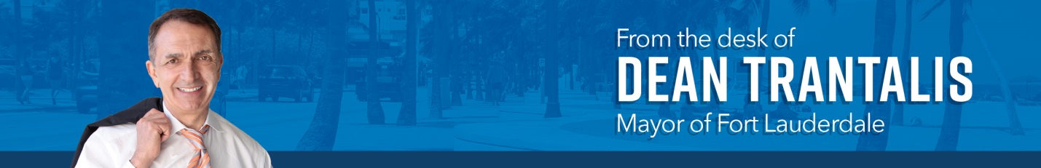

May 2021

Over the coming summer months, some amazing milestones will be reached in our city.

The new central sewer main will be completed and operational. Construction of a new police station and the renovation of War Memorial Auditorium will be underway. A new police chief should be on board. Upgrades to Parker Playhouse will be finished. And a new high-rise dive tower will be topped off as part of the ongoing makeover of the aquatic center.

And that is just the tip of what has been occurring to make Fort Lauderdale an even better place to live and work. We are making incredible progress in improving the quality of life of the community and ensuring we have an infrastructure that can serve us for many years to come.

- The central 54-inch sewer line. By end of June, the city is scheduled to complete the installation of the sewer pipe to replace the brittle and aging one that was the cause of numerous breaks in the Rio Vista and Coral Ridge neighborhoods.

- Other sewer and water projects. By July, the water main improvements being undertaken in the Victoria Park neighborhood will be completed, including the restoration of the streets. Water main work in Bermuda Riviera was completed last year, and improvements in Coral Shores should be done by October. Sewer work in both Flagler Village and Victoria Park is underway, as is the installation of a new line on NW 13th Street.

- Stormwater drainage. A three-year project to improve drainage and decrease flooding in the River Oaks and Edgewood areas will begin this fall. One critical part of the project began earlier – a 9-acre stormwater preserve in River Oaks – and will be substantially completed in May.

- Seawalls. Following last year’s completion of a new seawall on Isle of Palms, work progressed quickly to build a new seawall on Cordova Road and it is now finished as well. More than 2,000 linear feet of seawall was installed, which will help prevent flooding during the rainy season and king tides this fall. The road is scheduled to be repaved in June.

- Waterway cleanup. The city continues to take seriously the need to ensure our canals and waterways are clean. Late last year, we introduced weekly monitoring of water quality at key locations across the city and publicize that data on our website and social media.

Remediation work at George English Lake will enter a new phase in June as contractors begin the removal of sediment. Dredging in the Tarpon River is awaiting final permitting, and an assessment of the best course of action for the Himmarshee Canal is being prepared for delivery to state environmental regulators.

- New police station. We are hoping to break ground this summer on a new police station and complete the work by fall 2023. Voters overwhelmingly approved the project in 2019. The current station is at the end of its life --- out of date for current law enforcement needs and incapable of withstanding a major hurricane.

- New fire station. The city recently opened a new fire-rescue station to improve coverage in the southeastern areas of the city. Station 8 is a 10,000-square-foot facility located at 1717 SW 1st Ave. and houses two advanced life-support units.

- War Memorial Auditorium. In late May, we will officially begin construction on a major renovation to the War Memorial complex. When completed in the summer of 2022, War Memorial will feature ice rinks for public use as well as a training facility for the professional Florida Panthers hockey team. The Panthers will also take over operation of the auditorium, continuing its focus on family-friendly shows and events while relieving the city of the annual operating costs.

- Parker Playhouse. Renovation of this landmark theater will be completed in May. When it reopens for its fall schedule, guests will enjoy new lounges and a vibrant new lobby as well as a state-of-the-art sound system. The original façade and seating configuration remain.

- Aquatic center. Work on updating the aquatic center continues, with the topping-off of the iconic new 27-meter dive tower coming at the start of July. We are rebuilding the pools and expanding work to include improved locker rooms. When completed, the aquatic center will again be home to major swimming and diving competitions as well as a place for locals to enjoy recreational aquatics.

- Park improvements. The City Commission recently gave the green light to improvements at 39 community parks as part of the park bond initiative that voters approved.

- 17th Street Bypass. Design has begun on this new road through Port Everglades that should help alleviate traffic on SE 17th Street. Broward County promised to build the road as part of the planned convention center expansion.

So, this is a truly exciting time in Fort Lauderdale’s history. We are on the precipice of great things, and there is more to come.

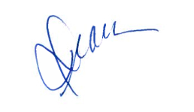
Yours,

Dean

